Finance Report
  - Immaculate Conception Parish Finance Committee
April 2022

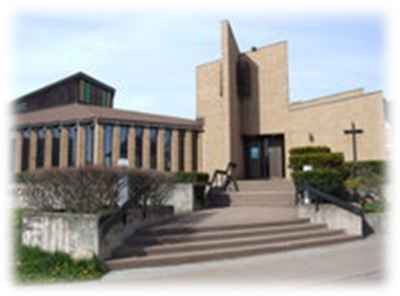

Dear Fellow Parishioners:

Happy Spring!

On behalf of the Finance Committee, we are pleased to present to you our year-end Financial Report and the Parish Budget for 2022. The Audit for 2021 is being completed and we expect the final report shortly. We will share that report with you as well when it is received.

It has been an interesting year as we continued to deal with COVID-19 as well as bring another Parish under our management and liturgical leadership – St. Kateri, Shubenacadie. We now have five church communities under Immaculate Conception Parish as one. The demands on Father Dariusz are significant.
As previously reported to the Parish, our revenue has been fairly stagnant for the past five years. In fact, for the past several years, we have relied on bequests (which is unexpected revenue) to help fund operations and prevent us from being in a deficit position at year end. COVID-19 presented additional challenges as we had far fewer people attending Mass, which impacted giving.
2021:
Income
Collections and Direct Deposits | $313,168
Capital Campaign | $106,611
Ministries | $38,353
COVID Wage Subsidy | $12,449
Miscellaneous | $41,352 (interest, mortgage, room & board)
Total Income | $511,934

Expenses
Church | $173,390
Hall | $1,149
Residence | $27,246
Administration | $107,459
Worship | $71,009
Ministries | $88,866
Diocesan Assessment | $44,041
Total Expenses | $513,160
Deficit | $1,226

We need to reverse this trend so that our Parish continues to be in a healthy position. We encourage all parishioners to continue to give weekly, and to set up direct deposit so that giving is consistent.

Budget 2022

Income
Collections and Direct Deposits | $313,499
All other Income | $107,655
Total Income | $420,655
Expenses
Church | $116,700
Hall | $3,000
Residence | $32,800
Administration | $83,050
Ministries | $125,158
Formation/Worship | $11,700
Diocesan Assessment | $46,247
Total Expenses | $418,655
Surplus | $2000

Capital Campaign
Our 2022 capital priority is to replace our 40 year old furnace and upgrade the heating/cooling system. We expect this to cost in the range of $70,000. Any parishioner willing to support this project can speak with Fr. Dariusz.
While we would love to say yes to every request for project support, it is simply impossible within our limited operational budget.

This budget does not include any capacity to support new initiatives or new mission projects. While we encourage and support new ideas, projects and initiatives, they must be self-financing through sponsorships and/or fund raising.

A friendly reminder that no ministry or parishioner has the authority to authorize expenditures on behalf of the Church. All purchases must be prior approved by the Finance Committee or Fr. Dariusz.

Thank you for your continued support. We would not have a vibrant Immaculate Conception Parish without you.
Please don’t hesitate to contact me, or Father Dariusz, at any time, should you wish to discuss this report or the activities of the Finance Committee.

Together in Christ,
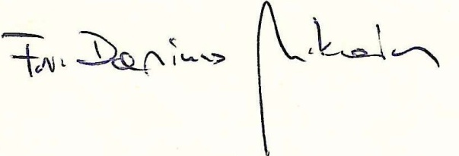

Fr. Dariusz, Dianne Kelderman,
Parish Priest Finance Committee Chair
893-7188 899-0070
icc.dariusz@eastlink.ca diannefk@eastlink.ca

