Finance Report
  - Immaculate Conception Parish Finance Committee
June 2022

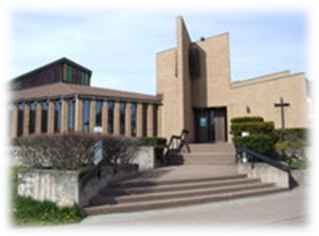

Dear Fellow Parishioners:

On behalf of the Finance Committee, we are pleased to present to you our summary year-end Financial Report and our Audit Report.

As previously reported in our April report, we ended the 2021 fiscal year with a slight deficit of $1226.
The trend for 2022 is concerning. To date, we are showing a deficit of $13,608. This includes significant increases in fuel and utilities, increased use of the kitchen and Campbell Hall and a $7000 expense to have the survey completed at St. Ambrose in Londonderry. As you will recall from the April report, we have budgeted for a modest surplus of $2000, so significant increase in revenue or a significant decrease in expenses will be necessary over the next six months to reach that goal.
As previously reported to the Parish, our revenue has been fairly stagnant for the past five years. In fact, for the past several years, we have relied on bequests (which is unexpected revenue) to help fund operations and prevent us from being in a deficit position at year end. COVID-19 presented additional challenges as we had far fewer people attending Mass, which impacted giving.
We are pleased to report that our 2021 independent audit has been completed and it was a “clean” report, meaning no issues were identified that would cause a lack of confidence in the financial statements or the internal controls of our Parish.
A sincere “thank you” to Joe Nicholson for conducting the audit and having submitted it directly to the Diocese on our behalf.

At the June Finance Committee meeting, I tendered my resignation as Chair of the Finance Committee. I have held this position for the past eleven (11) years, which is a long time. With new leadership arriving soon, it is time to move on and allow others to bring their skills and commitment to the finance committee.
I would like to express my personal thanks for your support and trust in me and our Committee during these years.
I’m sure the new Chair and committee members will be announced in September.
Thank you for your continued support. We would not have a vibrant Immaculate Conception Parish without you.
Please don’t hesitate to contact me, or Father Dariusz, at any time, should you wish to discuss this report or the activities of the Finance Committee.

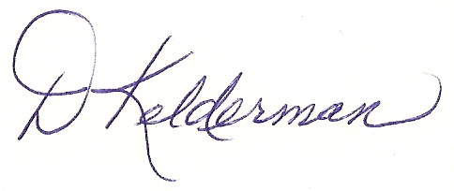
Together in Christ,
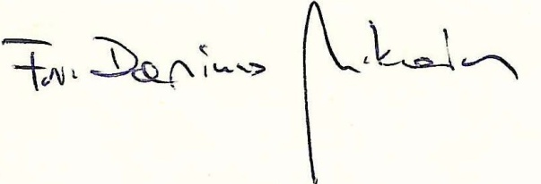

Fr. Dariusz, Dianne Kelderman,
Parish Priest Finance Committee Chair
893-7188 899-0070
icc.dariusz@eastlink.ca diannefk@eastlink.ca

